Chinese Dragon Watercolor Illustration

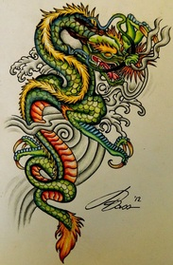

Project Objectives:

T.S.W. – Explore the art and culture of China focusing on the importance of the Chinese dragon during the Chinese New Year
T.S.W. – Create a 2-d Chinese dragon illustration demonstrating knowledge of pen and ink drawing techniques as well as watercolor painting techniques.
T.S.W. – Self assess and critique their work and the work of others by demonstrating knowledge of description, analysis, interpretation, and judgment.

Procedures:

1. Create two thumbnail sketches of Chinese Dragon. Use step by step drawing resources provided.
2. Create a full-page, full-color (if time permits) rough draft drawing of Chinese dragon.
3. Following a teacher demonstration, practice watercolor techniques (wet in wet, dry brush, flat wash, and graded wash).
4. In pencil only, draw Chinese dragon on FINAL watercolor paper provided.
5. Outline Chinese dragon in black sharpie (or other permanent marker).
6. Begin adding color using a variety of watercolor painting techniques. (Oil pastels and crayons are optional).
7. Add embellishments if time permits.

Grading Procedures:

· Artwork must display characteristics of Chinese dragons.
· Student must use at least two watercolor techniques.

*See general project rubric.

