Half & Half Drawing
Adobe Photoshop
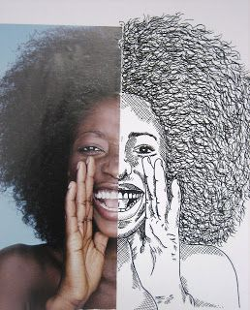

Essential Question: How does a traditional art medium differ from digital art media?

Project Outcomes:
- T.S.W. Demonstrate knowledge of basic photoshop tools including opening files, the crop tool, the brush tool, and the layers palette.
- T.S.W. Demonstrate knowledge of the art element line and the art principles balance and emphasis.
- T.S.W. Self assess and critique their own work as well as the work of others using the language of art (description, analysis, interpretation, and judgment).

Procedures:
- Select a photo from the folder, or choose one of your own (must be close-up).
- Crop the photo and create a new layer to draw on.
- Using the brush tool, re-create the second half of the portrait using line drawing techniques.
- Save your work.

Grading Criteria:
- Please refer to general “Studio Project” grading rubric on www.townsendartclass.weebly.com

