Name Sculptures

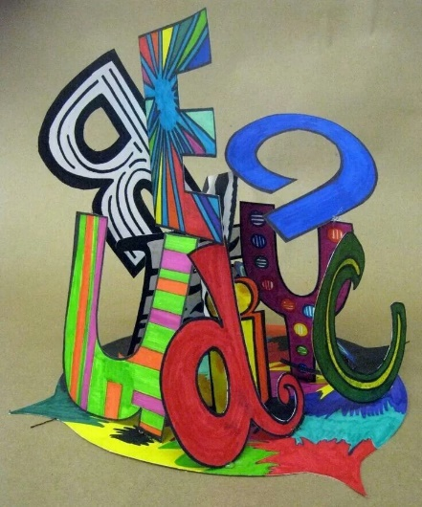

Project Objective(s):
- Students will demonstrate prior knowledge of the Elements of Art by creating a 3-dimensional name sculpture.

Procedures:

- Using ONLY pencil, create your first name and last initial using block or bubble letters.
- Outline block letters in marker (any color)
- Use the markers to decorate the letters.
- Write your first name, last name, and class period on the back of the construction paper.
- Use colored pencil to decorate the front of the construction paper with patterns.
- Cut out the letters.
- Attach the letters to the construction paper to create a sculpture.

Grading:
Your project must include:
1. Your name.
2. Color and patterns.

*Refer to general grading rubric.

