Personality Swirls
Let’s get to know you while creating radial designs!
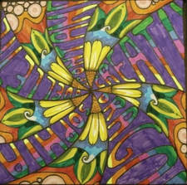

1. Find the EXACT center of the square, create curved lines radiating out. YOU SHOULD HAVE 12 SECTIONS!!

2. In every other section, YOU have to write the following words:
- First Name
- Last Name
- 4 words about YOU! (Adjectives to describe your personality, hobbies/interests, etc.)
- YOU can write these in any font/style you want.
- Try to 'stretch' the word out so it fills most of the section.

3. Draw a pattern/design of YOUR choice. You can keep the same pattern in all of the sections or you can mix them up, whatever you like. Come up with really creative solutions to this.

DRAW IN PENCIL FIRST!!

4. COLOR! Take your time…. It WILL SHOW!!

We will be displaying these so please do your personal best.

