Spooky Cave Paintings
Art Inspiration: Ancient Cave Paintings

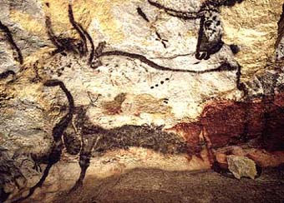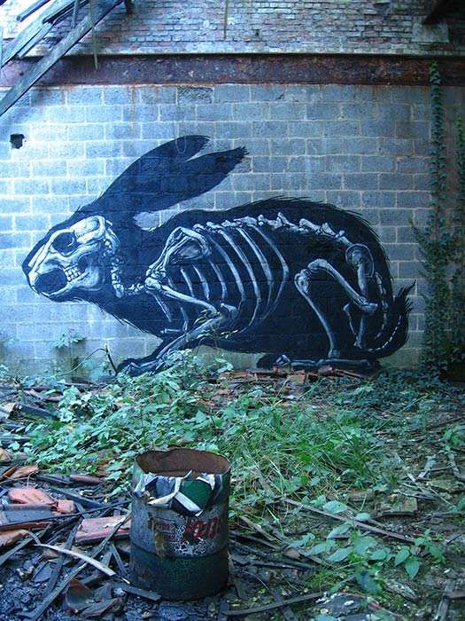
*Images found on Pinterest.
Procedure:
- Students will create 2 - 4 thumbnail sketches of animal silhouettes similar to that of ancient cave paintings.
- Students will research and draw skeletal structures of chosen animals.
- Students will create a full page rough draft of cave painting in sketchbook.
- Students will crumble paper to create background of cave painting.

Grading Criteria:
- Artwork must represent style of ancient cave paintings.
- Accurately use chalk pastel techniques

*See general rubric.

