Symmetrical Name Tower

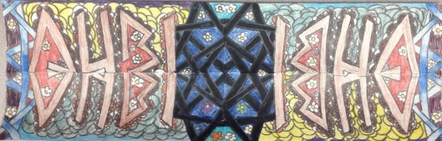

Project Objective(s):
1. Students will review and explore the art elements TEXTURE and PATTERN by filling in the background of their towers.
4. Students will explore the design principles EMPHASIS by creating a bold, colorful name design in the middle of their paper.

Procedures:
1. Fold paper in half like a hotdog.
2. Using ONLY pencil, Write or print your first name. *Write big or it will not show up!
3. Go over the pencil with black marker.
4. Fold it back in half...you will be able to see the black marker through the paper....
5. Trace over that with pencil and then black marker again.
6. Open the paper. Trace the name one more time.
7.USE THE COLORING TECHNIQUES YOU MAY HAVE LEARNED IN CLASS (shading, stippling, hatching, cross-hatching, squiggle, burnishing, outline/color-in) to fill in the letters.
8. Use patterns to fill in the negative space around the letters.

Grading:
Your project must include:
1. Your name accurately mirrored (symmetrical).
2. Coloring techniques MUST be used.

*Refer to general grading rubric.

